**Project Description:**

Tsek is a mobile app designed to help students manage their academic responsibilities. Ideal for high school and college students, Tsek features a progress/deadline tracker, motivational quotes, and a Pomodoro timer. These tools help users stay organized, prioritize tasks, and maintain focus. With a user-friendly interface and essential notifications, Tsek aims to enhance productivity and improve academic performance.

**Requirements Summary**

| **MINIMUM REQUIREMENTS** | Processor Cores | Single Core |
| --- | --- | --- |
| OS | Android 4.4 (KitKat) |
| RAM | 2 GB |
| **RECOMMENDED REQUIREMENTS** | Processor Cores | Quad Core |
| OS | Android 8.0(Oreo) |
| RAM | 4 GB |
| **OTHER REQUIREMENTS** | Permissions | Notifications and Storage |

*Table 1. System Requirements*

To accommodate all users, the minimum requirement is 2 GB of RAM which is sufficient to be used in any device.

**Prototype Description**

The Tsek app prototype was made using Microsoft PowerPoint. This prototype features interactable buttons, navigational windows, and additional screens for editing the Checklist and Pomodoro Timer tasks.  
  
[CATABE_APPLICATION.ppsx](https://malayancollegesmindanaoo365-my.sharepoint.com/:p:/g/personal/mecatienza_mcm_edu_ph/EUMO4IZDI8RLkW7XE4SvqUMBYlACyLVDyfGhs4DxTiWNUw?e=sGamwt)

**User Scenario**

Billy and Nicole are college students and have been dealing with tasks and assessments given to them by their professors. They needed help keeping track of their tasks and managing them. Billy found an application named “Tsek” which had features that could help with their situation.

**Prototype Design**

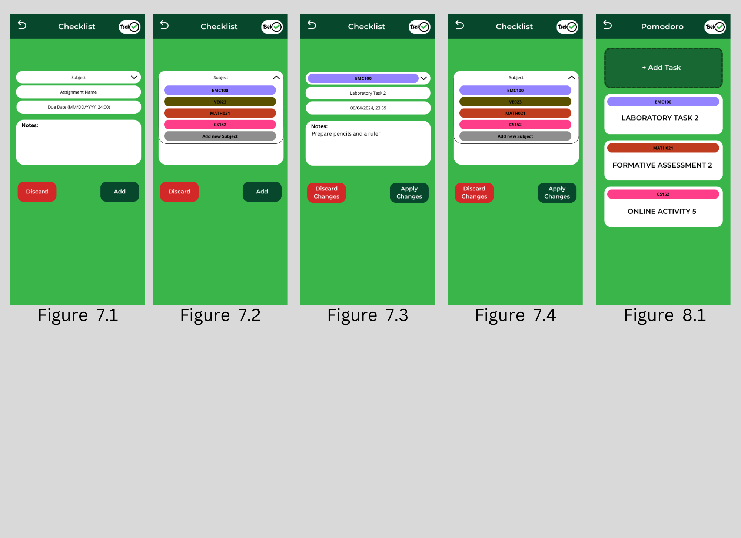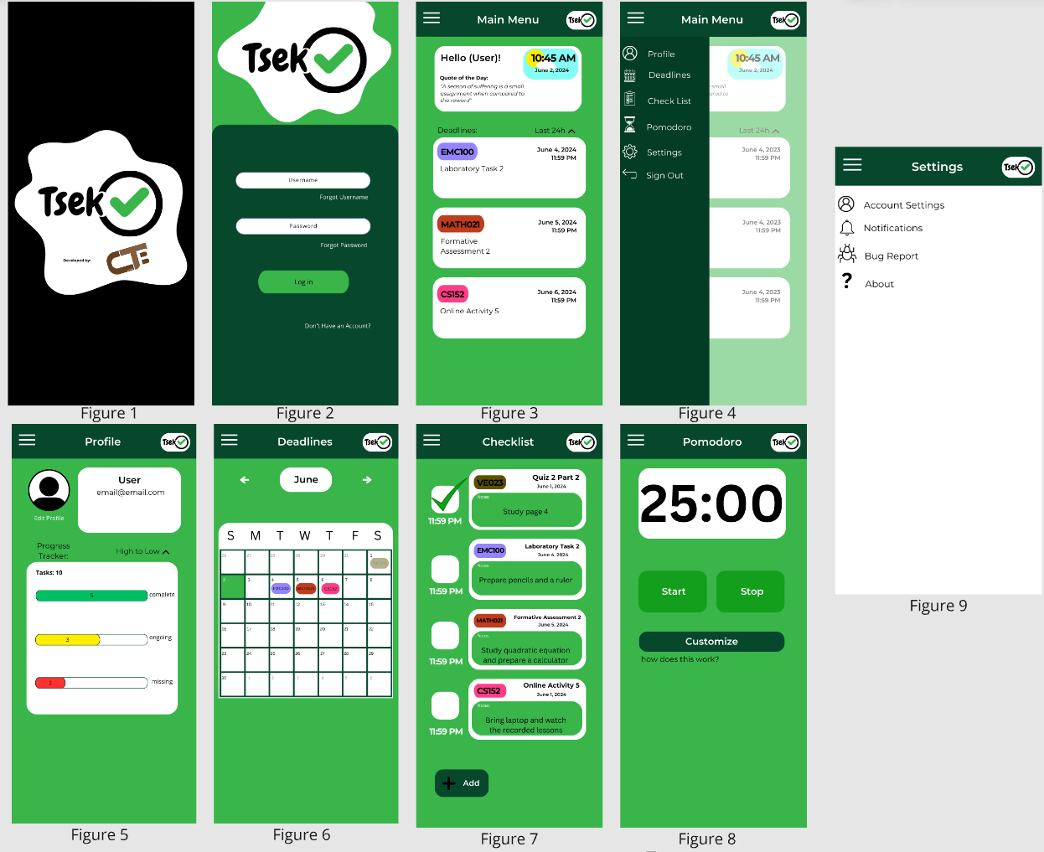

Upon launching the application for the first time, the opening screen shows the application and developer logos, serving as a quick entry point. If users haven't logged in or don't have an account, they see an initial setup screen with options for recovering usernames or passwords and a signup button. After logging in, the Main Menu screen welcomes users by name, featuring a dynamic clock, a daily motivational quote, and a simple view of upcoming deadlines.

A collapsible burger menu (A.K.A. the Navigation Bar) reveals additional sections: Profile, Deadlines, Checklist, Pomodoro, Settings, and sign-out. The Profile section displays essential information, allows profile editing, and tracks task progress. The Deadlines section presents a calendar with navigation to past and future months, highlighting completed tasks and the current date. The Checklist section lists tasks with details such as subject name, task name, date, and user-added notes. The pages in Figure 7.1-7.4 display the editing section of the Checklist function. The Pomodoro timer helps manage task time with default work and break periods, featuring start, stop, and a customize button for adding tasks to prioritize. Figure 8.1 shows the page for adding tasks in the Pomodoro function. The Settings section provides access to account management, notification preferences, bug reporting, and application version details.

**Rationale:**

The primary aim of Tsek's development is to offer students a straightforward method to manage their academic tasks. The app focuses on usability and simplicity, ensuring that users can easily track deadlines and organize their responsibilities. Upon launching the app, users see a welcoming screen, and if needed, an initial setup process for new accounts. The Main Menu provides a personalized greeting, a dynamic clock, motivational quotes, and a quick view of deadlines. With sections like Profile, Deadlines, Checklist, Pomodoro, and Settings easily accessible, Tsek streamlines task management. This design enhances productivity and academic performance with minimal effort, making it an effective tool for students.

**Changes to requirements**

No specific changes were made to the system requirements; however, two major changes were made to the usability criteria for the prototype. These changes were necessitated by the lack of resources. Initially, we aimed to implement internet connectivity and account syncing features within the application. However, due to time constraints, we implemented a local account management system that does not require internet connectivity instead. This adjustment ensures users can still manage their tasks effectively without relying on an internet connection.

**Initial Evaluation Plan:**

We conducted an evaluation for the Tsek prototype with college students as participants. The evaluation was carried out online using platforms like Microsoft Forms for ease of access. Using a two-part evaluation first has a Likert scale with general evaluation and the second focuses on interactive areas. With that, the objective was to identify the application's general functionality and interactivity to the user.